Capstone Project Report

Indian Restaurant in Paris

Tarun Kedia

Table of Contents

1 Introduction 2

**1.1** **Background** 2

**1.2** **Business Problem** 2

**1.3** **Interest** 2

2 Data 3

**2.1** **Location Data Gathering** 3

**2.2** **Restaurants Data Gathering** 4

3 Methodology 6

**3.1** **Data Analysis** 6

3.1.1 Data Calculations 6

3.1.2 Heatmap Explorations 6

**3.2** **Clustering Algorithm** 9

4 Results and Discussion 11

5 Conclusion 11

6 Future Work 11

List of Figures

[Figure 1. Visualization of the Neighbourhoods around the Louvre Museum 3](https://servicenow-my.sharepoint.com/personal/tarun_kedia_servicenow_com/Documents/CCP/Capstone%20Project%20Report.docx#_Toc41250620)

[Figure 2. Dataset of the 364 neighbourhoods shown in Figure 1 4](https://servicenow-my.sharepoint.com/personal/tarun_kedia_servicenow_com/Documents/CCP/Capstone%20Project%20Report.docx#_Toc41250621)

[Figure 3. All the Paris' Restaurants. Indian Restaurants are in red 5](https://servicenow-my.sharepoint.com/personal/tarun_kedia_servicenow_com/Documents/CCP/Capstone%20Project%20Report.docx#_Toc41250622)

Figure 4. List of all Restaurants and Indian Restaurants 5

Figure 5. Data Frame Snapshot 6

[Figure 6. Heatmap showing all the Restaurants in Paris 7](https://servicenow-my.sharepoint.com/personal/tarun_kedia_servicenow_com/Documents/CCP/Capstone%20Project%20Report.docx#_Toc41250625)

Figure 7. Heatmap of only Indian Restaurants in Paris. 8

Figure 8. Highlights the new area of Interest in Louvre and Panthéon boroughs 8

Figure 9. Favourable Locations in the area of interest 9

Figure 10. The 54 locations clustered in 7 zones 10

Figure 11. Addresses of the 7 clusters' centers 10

# **Introduction**

This project is a part of the Data Science Specialization Course - IBM

## **Background**

Paris, the city of love, is one of the major tourist attractions of the world. As per Wikipedia, about 18 million people from round the world visit Paris yearly for tourism generating a huge source of income for the people. And where there’s tourists, there be lots of restaurant and other tourist opportunities. Secondly, Paris has a very diverse social status. People from all over the globe come and stay or visit here. It is a cultural center of the world as it has been throughout the history. It has many such cultural centers one of them Louvre Museum, one of the largest museums on planet and home to the most famous painting in the world, The Mona Lisa. We will be concentrating on this Museum in this project.

When we combine these two factors, we see a great opportunity to share our Indian culture in the form of Indian cuisine and taste in the city of everyone. Not just from a financial perspective but also from the cultural position, setting up an Indian Restaurant in Paris can be a huge success.

## **Business Problem**

In this project, we will try to find some good options to set up a restaurant in a city. This project specifically targets the city of love, Paris and we wish to setup an Indian Restaurant.

We will try to find locations which are less crowded with restaurants and narrow down the areas having no Indian Restaurants. Another important preference is to keep the restaurant close to the iconic Louvre Museum. This location is preferable not only because of the Museum’s importance but also because it is geographically in the centre hub of the city.

## **Interest**

The project is highly interesting as it allows us to explore the city of Paris, it’s various boroughs and find a suitable location for an Indian restaurant. It helps develop business values and understand the factors involved.

# **Data**

Some of the important factors underlying in our problem statement which will influence how we gather data are:

* Number of restaurants currently present in a given neighbourhood
* Number of Indian Restaurants in the neighbourhood
* Distance of each Indian Restaurant from each other
* Distance of the neighbourhood from the Louvre Museum

For doing so, we are going to use the regularly spaced grid of locations, centred around the Louvre, to get our neighbourhoods. Following data sources will be needed to extract/generate the required information:

* Centres of candidate areas will be generated algorithmically and approximate addresses of centres of those areas will be obtained using **Tom Maps API reverse geocoding**
* Number of restaurants and their type and location in every neighbourhood will be obtained using **Foursquare API**
* Coordinates of Louvre centre will be obtained using **Geolocator**

## **Location Data Gathering**

The first and foremost step is to gather the coordinates of the Louvre Museum. This is done using the **Geolocator API.**

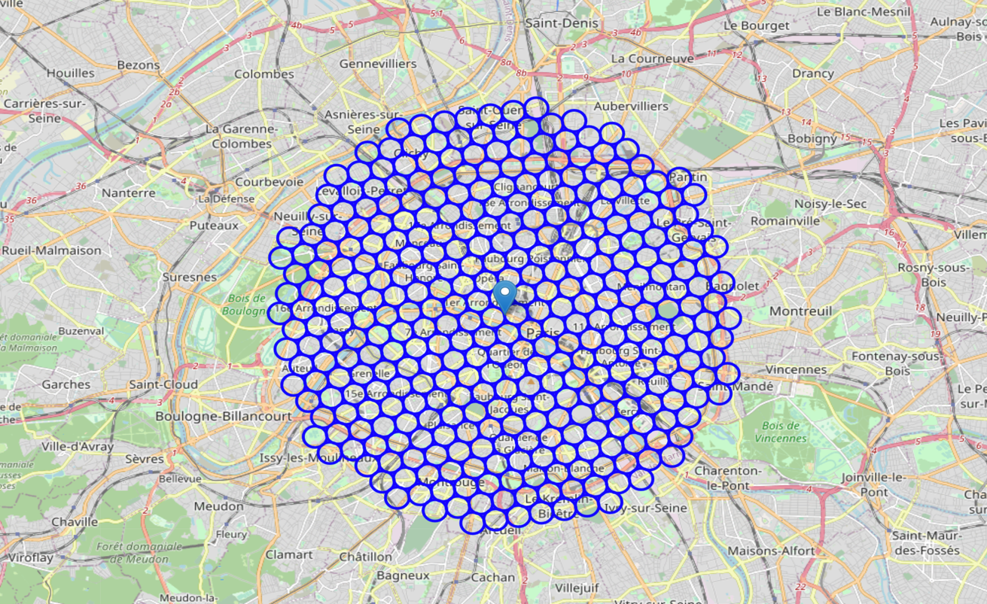The geographical coordinate of Louvre Museum are 48.86114, 2.33802.

Figure 1. Visualization of the Neighbourhoods around the Louvre Museum

We, then, create a grid of area candidates, equally spaced, centered around Louvre and within ~6km from Louvre. Our neighborhoods will be defined as circular areas with a radius of 300 meters, so our neighborhood centers will be 600 meters apart. We create a hexagonal grid of cells: we offset every other row, and adjust vertical row spacing so that every cell center is equally distant from all its neighbors. Below in Figure 1, we can see the grids around the Louvre. These neighborhoods are a total of 364.

Once we have the coordinates for these neighborhoods, we then find an approximate address for them. We use the Tom API for this **reverse geocoding.** Once we have the addresses in a list, we then convert them into a Pandas dataframe, and we get our first dataset. Below in Figure 2, we see a snapshot of the dataset containing:

* Address
* Latitude & Longitude
* X & Y Coordinates (Converted form of Latitude & Longitude)
* 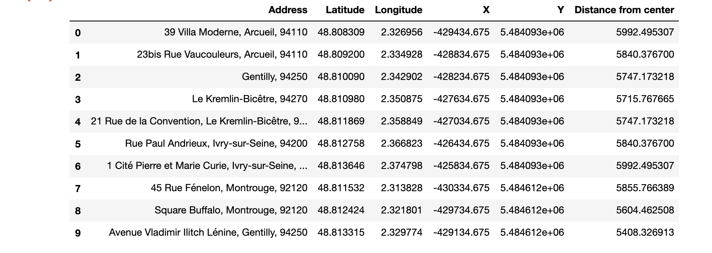Distance from the center (Louvre Museum)

Figure 2. Dataset of the 364 neighbourhoods shown in Figure 1

## **Restaurants Data Gathering**

Now the next task is to get all the restaurants’ data. For this we used the fourscore API. We are interested in venues in 'food' category, but only those that are proper restaurants and not coffee shops, pizza places, bakeries etc. So, we will include in our list only those venues that have 'restaurant' in category name, and we'll make sure to detect and include all the subcategories of specific 'Indian Restaurant' category, as we need info on Italian restaurants in the neighborhood. We gather the Category IDs corresponding to the Indian Restaurants and ‘Food’ Category from the [Foursquare Website](https://developer.foursquare.com/docs/resources/categories).

In the Figure 3, we see the restaurants over the map of Paris. The Indian Restaurants are marked in red color, all other restaurants are in blue. Also, in Figure 4, we see the snapshots of the List of all restaurants and List of Indian Restaurants.

In the Table 1, we highlight a few statistics about the restaurants of Paris.

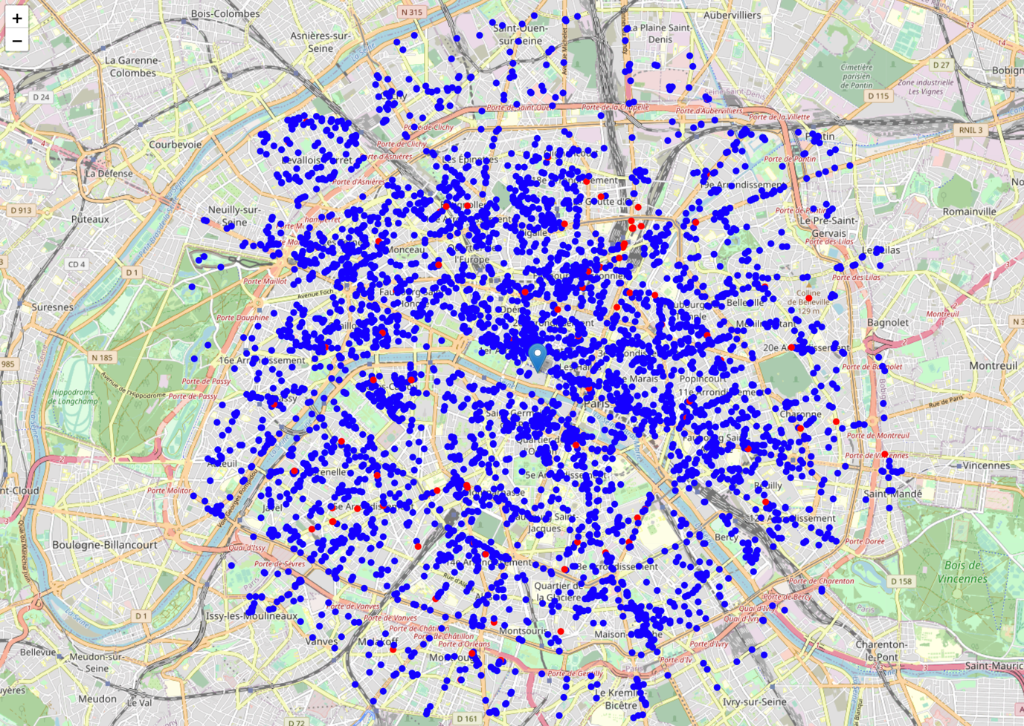

Figure 3. All the Paris' Restaurants. Indian Restaurants are in red

|  |  |
| --- | --- |
| *Table 1* | |
| Total number of restaurants | 4329 |
| Total number of Indian Restaurants | 87 |
| Percentage of Indian Restaurants | 2.01% |
| Average number of restaurants in neighborhood | 10.56868131868132 |

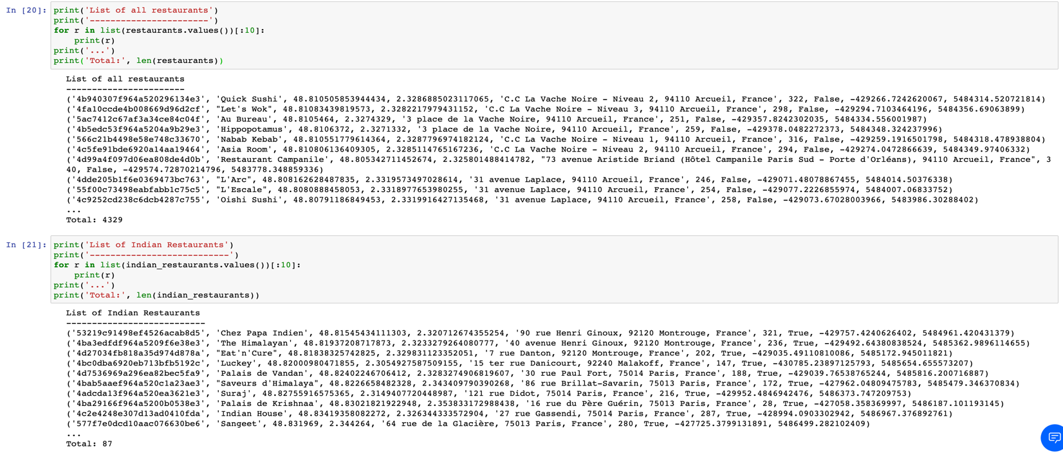

Figure 4. List of all Restaurants and Indian Restaurants

And with this we complete the data gathering process!

# **Methodology**

Now that we have all the restaurants in the area and we know the Indian Restaurants among them, we start analyzing the data to get the optimal result for a new Indian Restaurant. There are two major steps involved in this, analyzing the data to narrow down favorable locations and then clustering them together.

## **Data Analysis**

### Data Calculations

We start off with analysing the data gathered. First, we count the number of restaurants in each neighbourhood and find the average number of restaurants in an area of 300 metres. Similarly, we calculate the average distance to closest Indian Restaurant for each neighbourhood’s centre. We then receive the updated data frame as shown in Figure 5.

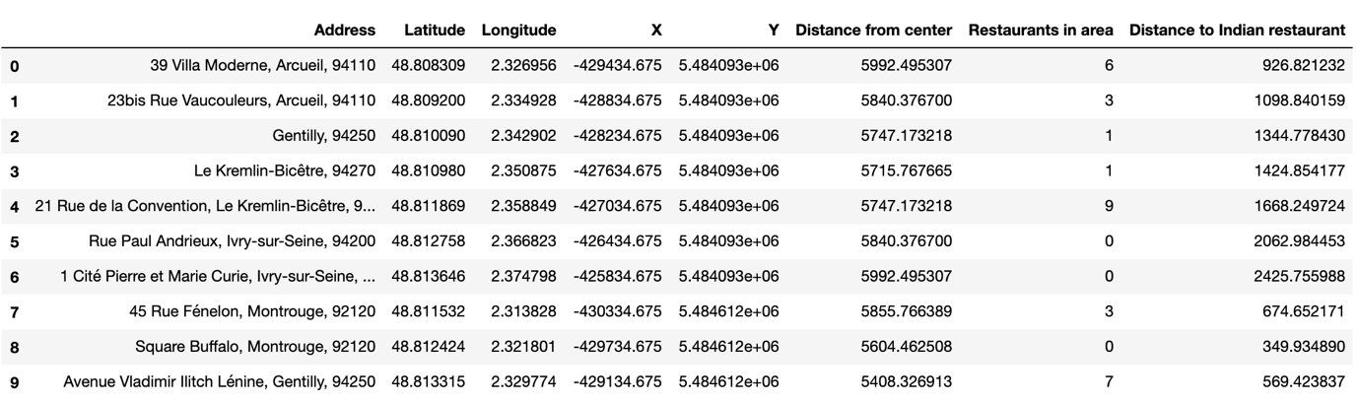

Figure 5. Data Frame Snapshot

From the above data frame, we can conclude one important conclusion, on average Indian restaurant can be found within appx 750 metres from every area centre candidate. Given that, Indian Restaurants are only 2% of the total restaurants in Paris, this number is not surprising. But now, we now the approximate distance our restaurant should be from other Indian Restaurants.

### Heatmap Explorations

We now create heatmaps to study the dataset. In the heatmap, we are highlighting the boundaries of the boroughs of Paris and also a radius of 1km, 2km and 3km from the Louvre Museum. We create the following heatmaps:

Figure 6. Heatmap showing all the Restaurants in Paris

* Heatmap showing the distribution of restaurants in Paris (Figure 6)

In the heatmap, we can see that the concentration of restaurants is very high in North, North-East and East of Louvre. There are few open pockets in the south and south-east of Louvre in the Louvre and Panthéon Boroughs.

* Heatmap showing the distribution of Indian Restaurants in Paris (Figure 7)

In this heatmap, we can see that the degree of hotness is very low. This is due to the fact that, Indian Restaurants compromise only about 2% of all the restaurants. We can see that the density is maximum in the North and North-East Region

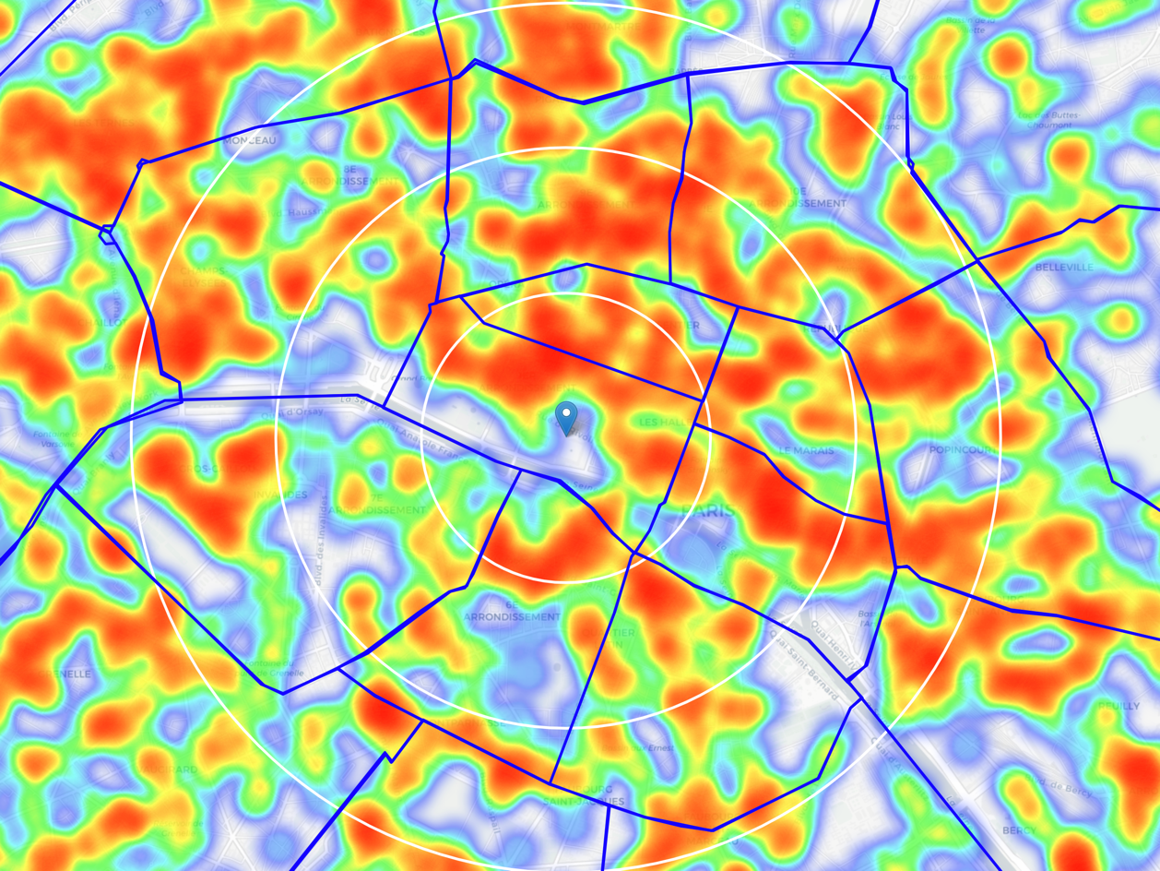From the above two heatmaps, we come to a decision to explore more towards the south of Louvre Borough and Panthéon Borough. Accordingly, we make adjustments to the centre of area of interest. This helps us narrow down our search for the optimum location while being nearer to the Museum. We can see the new area of interest in Figure 8.

In this area of interest, we filter out our favourable locations as follows:

|  |
| --- |
| Locations with no more than two restaurants nearby: 134  Locations with no Indian restaurants within 700m: 336  Locations with both conditions met: 54 |

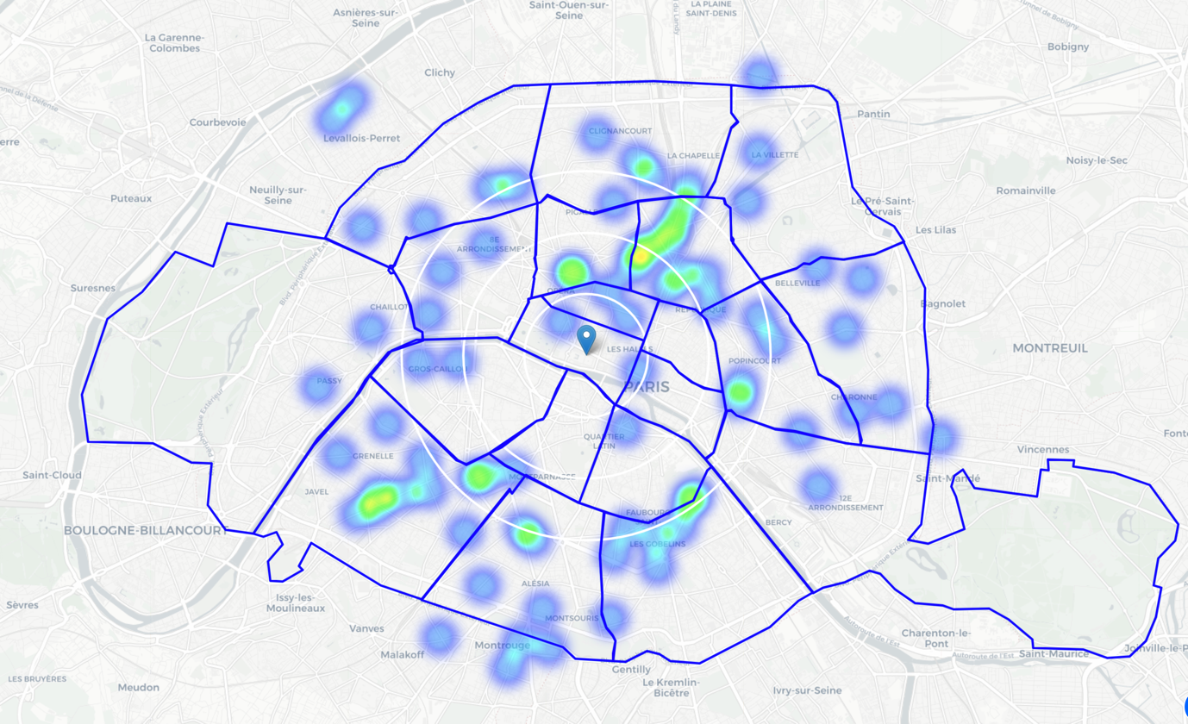

Figure 7. Heatmap of only Indian Restaurants in Paris.

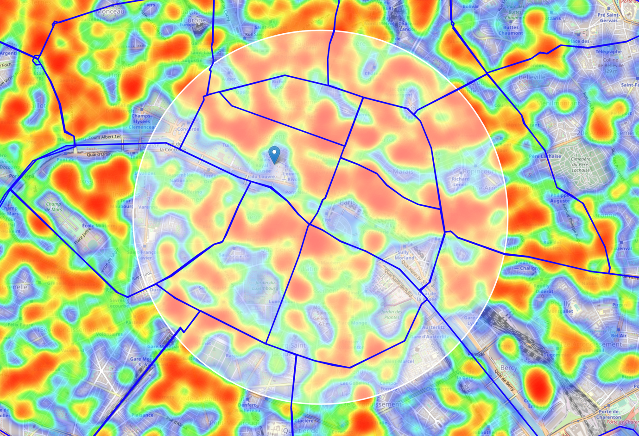

Figure 8. Highlights the new area of Interest in Louvre and Panthéon boroughs

We are now ready to visualize the favourable locations which are of interest to us and meet our business requirements. Figure 9 shows these locations.

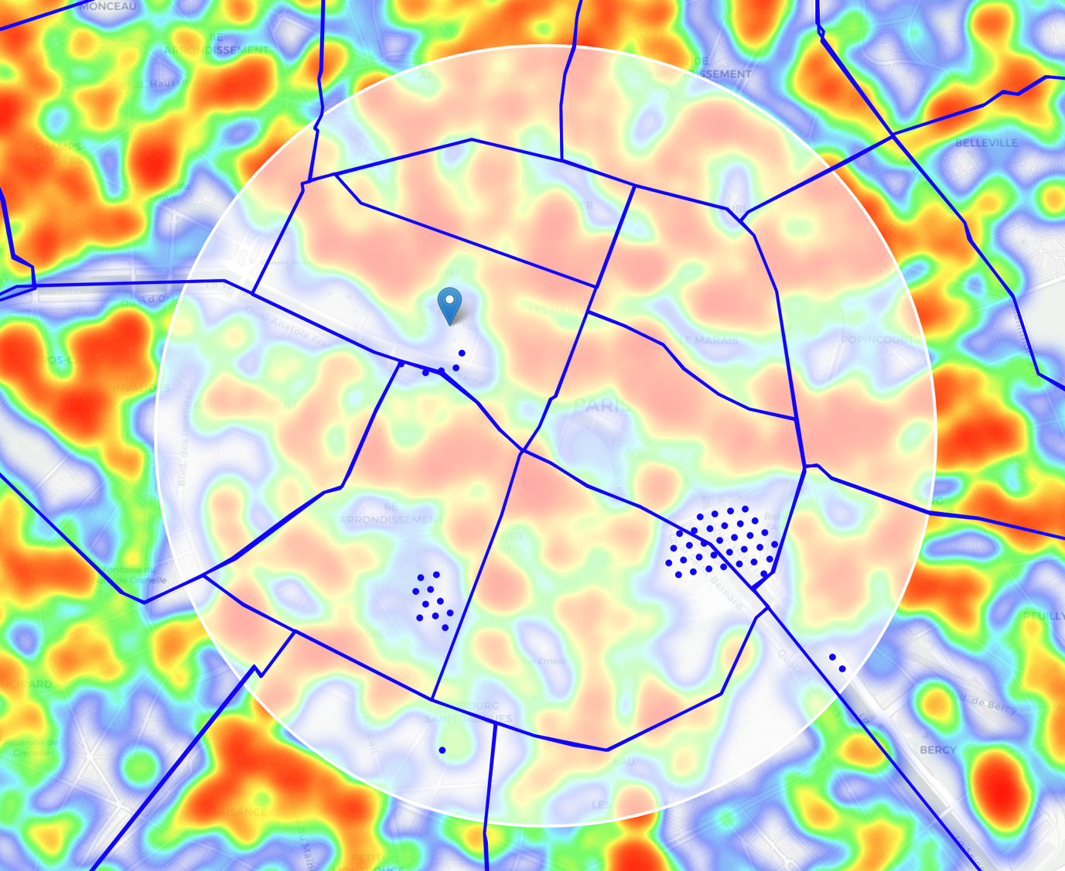

Figure 9. Favourable Locations in the area of interest

## **Clustering Algorithm**

Now that we have the locations, or in other words, data points with us, we start clustering them into 7 zones.

We perform the **k-means clustering** algorithm on these 54 datapoints. We receive the following 7 clusters on the map (Figure 10). Once we have these 7 clusters, we then find the address of the centres of these 7 clusters. These are the areas which are most favourable for opening the restaurant as they satisfy our initial requirements.

We can observe from the map that most of this area lies either in Panthéon and Louvre Borough. Some of the favourable locations are also in Luxemburg Borough and a few are outliers.

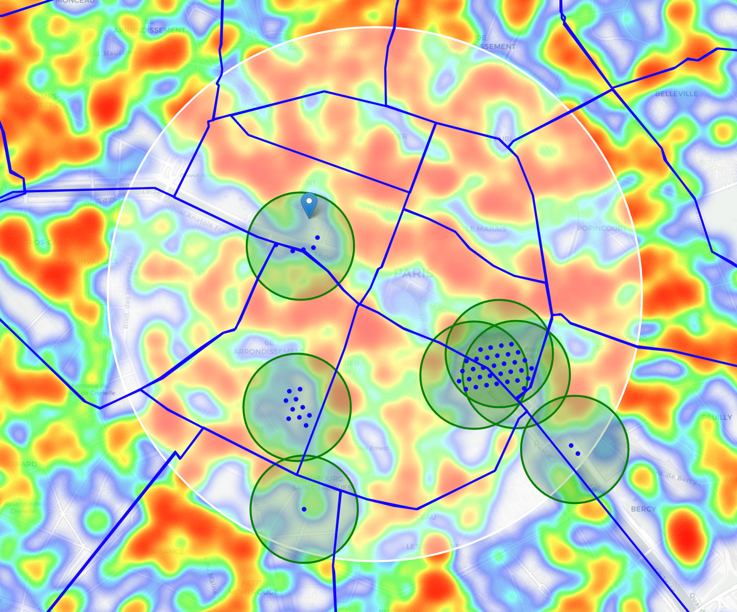

Figure 10. The 54 locations clustered in 7 zones

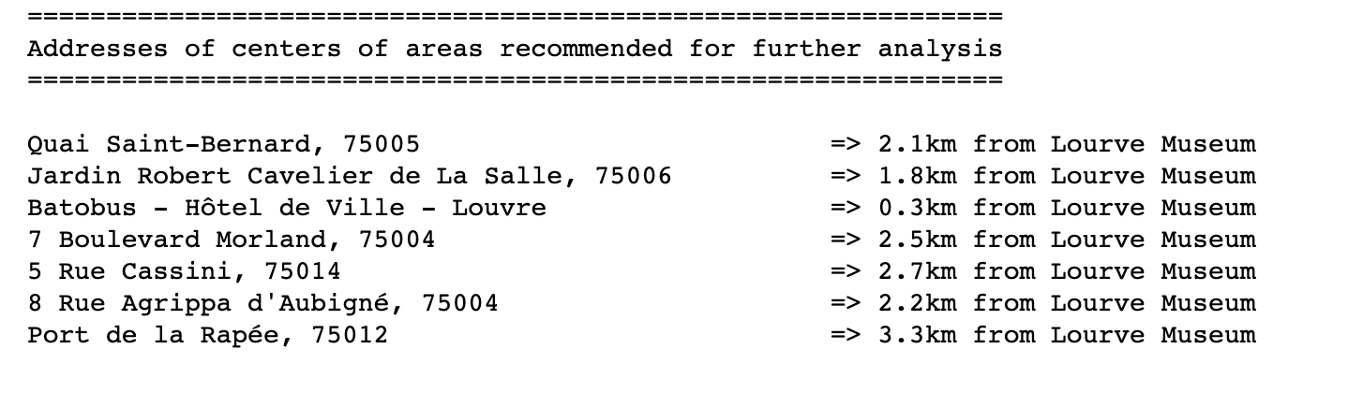

Figure 11. Addresses of the 7 clusters' centers

In the above Figure 11, we can see the centers of these 7 clusters and there distance from the Louvre Museum. The most favourable being ‘**Batobus, Hotel de Ville – Louvre**’ which is within 300 metres of the Louvre Museum. Of course, many other factors such as financial and legal requirements are not taken into account but based on the initial requirements, we have suitable candidates to look into.

# **Results and Discussion**

We discovered from our analysis that Paris has a huge number of restaurants. We found that the area around the Louvre Museum (center of the city) is densely covered with restaurants, highest concentration being north, north-east and south-east of the Museum. So practically, we shifted our focus to the south and south-east of the Museum which is potentially the best area to open up the new Restaurant as it is closer to the area of interest as well as have less concentration of restaurants. In our analysis, we discovered that this area lies mostly south of Louvre borough and Panthéon Borough. Both these areas provide a great offering of tourism popularity, strong economic advantage and lie in the heart of the city of love.

Once, we shifted out focus to the said boroughs, we narrowed down the search based on the fact that no two restaurants were within 250 meters and no Indian restaurant was closer than 700 meters. These led us to discover 54 such locations which can be favorable. We finally clustered them into 7 zones and generated addresses of the centers of these zones using reverse geocoding.

# **Conclusion**

We started off to identify favorable locations for a new Indian restaurant close to the Louvre Museum. We wanted to have a location, close to Louvre, having lesser number of restaurants and no Indian restaurants in the vicinity. We identified the different neighborhoods, the density of the restaurants in those areas and finally analyzed them for points which matched our requirements. We used Tom API and Foursquare API for this purpose. After identifying those locations, we clustered them into areas of interest and addresses of those zones were created using k-means clustering algorithm

We conclude from the analysis that we found many such locations in the Panthéon Borough and some close locations in the Louvre Borough itself. The most favourable being ‘**Batobus, Hotel de Ville – Louvre**’ which is within 300 metres of the Louvre Museum.

# **Future Work**

Many factors such as financial asks and legal conditions were not considered. Enhancing the model with those parameters will further narrow down the search and provide a more efficient solution. Also, the terrain was not filtered in the above project so we received some favourable points in the river Seine which follows through Paris. Further filtering will definitely improve the results.